**CA 2 : GenAi**

**Name : Vaishnavi Dhengare**

**Section : B**

**PRN: 21070521087**

**Q:6 Generate a model to represent a mathematical equation, write a program to parse the**

**equation, and ask for input for each parameter.**

**Step 1: Define a Mathematical Model**

choose a quadratic equation for this example:

ax2+bx+c=0ax^2 + bx + c = 0ax2+bx+c=0

Where:

* aaa, bbb, and ccc are coefficients.
* xxx is the variable we want to solve for.

**Step 2: Write a Program to Parse the Equation**

We'll use Python for this task. We'll create a program that:

1. Takes the coefficients aaa, bbb, and ccc as input from the user.
2. Solves the quadratic equation using the quadratic formula:

x=2a−b±b2−4ac​​

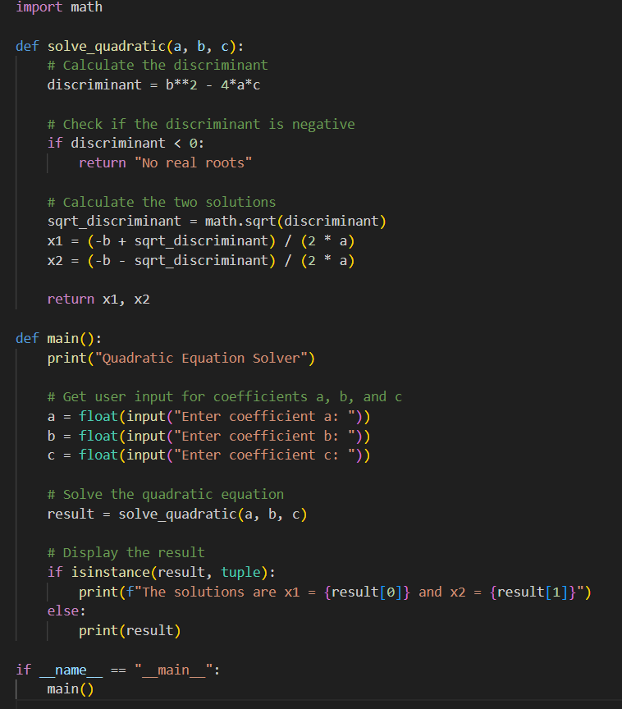

**Input Parameters**

Once you run the script, it will prompt you for the coefficients a, b, and c. Here’s how you’ll input them:

1. **Enter Coefficient a**: You will see the prompt:

Enter coefficient a:

Type the value for a and press Enter. For example:

1

1. **Enter Coefficient b**: Next, you will be prompted:

Enter coefficient b:

Type the value for b and press Enter. For example:

-3

1. **Enter Coefficient c**: Finally, you will be prompted:

Enter coefficient c:

Type the value for c and press Enter. For example:

2

**Example Interaction**

Quadratic Equation Solver

Enter coefficient a: 1

Enter coefficient b: -3

Enter coefficient c: 2

The solutions are x1 = 2.0 and x2 = 1.0

**Explanation of Results**

* If the discriminant (b^2 - 4ac) is positive, the script will output two real solutions.
* If the discriminant is zero, the script will output one real solution (both solutions are the same).
* If the discriminant is negative, the script will indicate "No real roots" as it doesn't handle complex solutions in this version.

**Q:3 Generate a model for an Insurance company to hold information on the insurer's vehicle,**

**and create a chart of monthly, yearly, and qtrly premiums based on no. of years of insurance**

**where in each year, the value of the vehicle depreciates by 7%.**

To create a model for an insurance company that holds information on a vehicle and calculates premiums based on depreciation and the number of years insured, we need to:

1. Define a data model for the vehicle.
2. Implement depreciation calculation.
3. Compute the premiums based on the depreciated value of the vehicle.
4. Create a chart to visualize the premiums over different time periods.

Let's walk through these steps.

1. Define the Data Model

We need a class to hold the vehicle's information and to perform calculations related to insurance premiums. Here's a simple Python class for this:

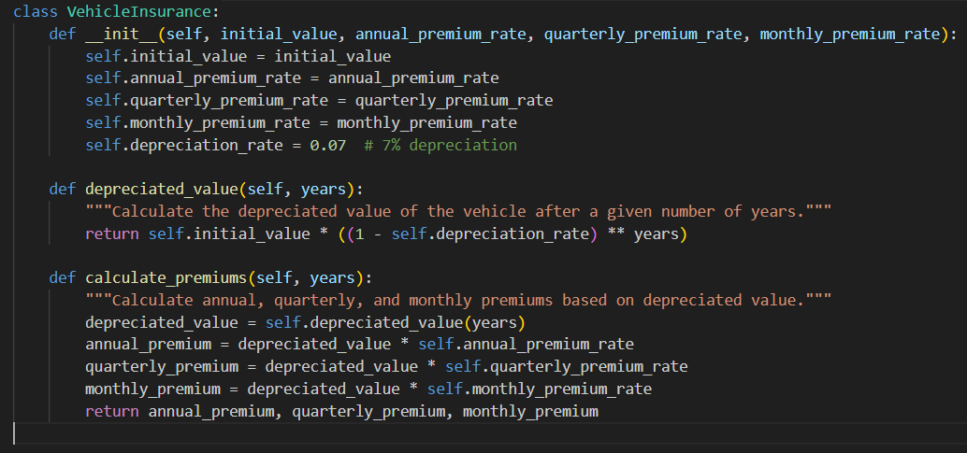

**2. Implement Depreciation Calculation**

The depreciated_value method in the VehicleInsurance class calculates the value of the vehicle after depreciation for a given number of years.

**3. Compute Premiums**

The calculate_premiums method computes premiums based on the depreciated value. We use rates for annual, quarterly, and monthly premiums, which are assumed to be given or fixed.

**4. Create a Chart**

To visualize the premiums, we can use Python's matplotlib library. Here’s how you can generate the chart:

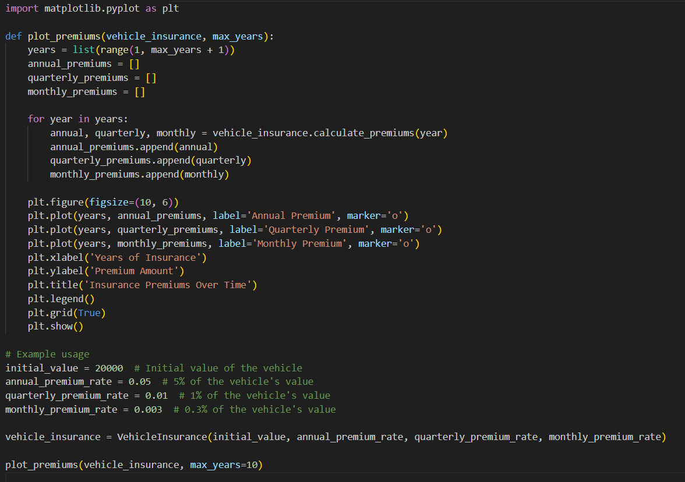

**Explanation**

1. **Data Model**:
   * VehicleInsurance class holds information about the vehicle and calculates premiums.
   * depreciated_value computes the vehicle’s value after a given number of years, accounting for 7% annual depreciation.
   * calculate_premiums uses the depreciated value to compute annual, quarterly, and monthly premiums.
2. **Chart Generation**:
   * plot_premiums function generates a chart showing how premiums change over time for up to max_years.
   * It plots annual, quarterly, and monthly premiums, giving a clear visual of how insurance costs evolve as the vehicle depreciates.